# IBM NAAN MUDHALVAN PROJECT SUBMISSION – PHASE-5

**TECHONOLOGY: APPLIED DATA SCIENCE**

STOCK PRICE PREDICTION

# PROJECT OVERVIEW:

1. Studying data science: It means a huge amount of information. It includes lots and lots of different pieces of information, like records or other large sets of data.
2. Using Data bases: It is like a special tool that helps us to organize and manage all the data sets.
3. Defunding Important Stuff: The data need to be completely checked out and finds only the important and useful bits.
4. Making a plan: A step by step plan should be made to work on this project.
5. Setting up Our Tools: Databases should be set to work efficiently.
6. Analysing and showing the results: All the data needs to be analysed carefully and it should be presented in such a way that it is easy to be understandable.

# DESIGN THINKING:

1. **Data Selection**: We have chosen the programming language dataset which is at the current trend.
2. **Database setup**: we have to set up the dataset for storing and managing the dataset.
3. **Data Exploration:** We are in the middle of developing queries and scripts to explore the datasets, extract relevant information, and identify patterns.
4. **Analysis Techniques**: We are yet to apply appropriate analysis techniques, like statistical analysis or machine learning, to uncover insights.
5. **Visualization**: We will design a visualization chart to present the analysis results in an understandable and impactful manner.
6. **Business Insights:** We will interpret the analysis findings to derive valuable business intelligence and actionable recommendations.

Dataset is taken from kaggle competition and it can be downloaded from here:

https://[www.kaggle.com/datasets/prasoonkottarathil/microsoft-lifetime-stocks-](http://www.kaggle.com/datasets/prasoonkottarathil/microsoft-lifetime-stocks-) dataset

Stock Price Prediction is the process of predicting what the demand for certain products will be in the future. This helps manufacturers to decide what they should produce and guides retailers toward what they should stock.

Stock predicting is the process of estimating future revenue by predicting how much of a product oe will sell in the next week, month, quarter, or year. At its simplest, a sales forecast is a projected measure of how a market will respond to a company's go-to-market efforts.

One of the most common methods used to predict stock is regression analysis. This method involves using historical sales data to train a model that can predict future sales.

The model can take into account factors such as past sales, marketing campaigns, and economic indicators to make its predictions.

## Demand forecasting is aim at improving the following process:

* Supplier relationship management
* Customer relationship management
* Order fulfillment and logistics
* Marketing campaigns
* Manufacturing flow management

## DATA GATHERING:

Dataset is taken from kaggle competition and be downloaded from here:

https://[www.kaggle.com/datasets/prasoonkottarathil/microsoft-lifetime-stocks-](http://www.kaggle.com/datasets/prasoonkottarathil/microsoft-lifetime-stocks-) dataset

## DATA DESCRIPTION:

You are provided with daily historical sales data. The task is to forecast the total amount of products sold in every shop for the test set. Note that the list of shops and products slightly changes every month. Creating a robust model that can handle such situations is part of the challenge.

## Machine Learning Algorithms:

Decision Trees and Random Forests: Useful for capturing complex relationships in the data.

Gradient Boosting Models (e.g., XG Boost, Light GBM): Excellent for predictive modeling and handling non-linear relationships.

## Predicting future sales involves using data science techniques. A simple algorithmic approach could involve:

1. **Data Collection:**

Gather historical sales data, including timestamps.

Include relevant features like promotions, holidays, and other factors affecting sales.

## Data Preprocessing:

Handle missing data and outliers.

Convert categorical variables into numerical representations.

Normalize or scale numerical features.

## Feature Engineering:

Create new features, like moving averages or seasonality indicators.

Extract relevant information from timestamps, such as day of the week or month.

## Model Selection:

Choose a regression model suitable for time-series data, like linear regression, decision trees, or more advanced models like ARIMA, SARIMA, or Prophet.

## Training the Model:

Split data into training and validation sets. Train the model on historical data.

## Model Evaluation:

Evaluate the model's performance using metrics like Mean Absolute Error (MAE) or Root Mean Squared Error (RMSE) on the validation set.

## Hyperparameter Tuning:

Fine-tune model parameters to improve performance.

## Prediction:

Use the trained model to predict future sales based on new data.

## Monitoring and Updating:

Regularly monitor the model's performance and update it as needed with new data.

## ALGORITHMS:

1. List out the goods and services you sell.
2. Estimate how much of each you expect to sell.
3. Define the unit price or dollar value of each good or service sold.
4. Multiply the number sold by the price.
5. Determine how much it will cost to produce and sell each good or service

## Importing Libraries:

**# EDA Libraries:**

import pandas as pd import numpy as np

import matplotlib.colors as col

from mpl_toolkits.mplot3d import Axes3D import matplotlib.pyplot as plt

import seaborn as sns

%matplotlib.pyplot inline import datetime

from pathlib import Path import random

## # Scikit-Learn models:

from sklearn.preprocessing import MinMaxScaler from sklearn.linear_model import LinearRegression from sklearn.metrics import mean_squared_error, mean_absolute_error, r2_score

from sklearn.ensemble import RandomForestRegressor from xgboost.sklearn import XGBRegressor

from sklearn.model_selection import KFold, cross_val_score, train_test_split

from sklearn.model_selection import KFold, cross_val_score, train_test_split

## # LSTM:

import keras

from keras.layers import Dense

from keras.models import Sequential

from keras.callbacks import EarlyStopping from keras.utils import np_utils

from keras.layers import LSTM

## # ARIMA Model:

import statsmodels.tsa.api as smt import statsmodels.api as smt

from statsmodels.tools.eval_measures import rmse import pickle

import warnings

1. Loading and Exploration of the Data
2. EDA (Exploratory Data Analysis)
3. Determining Time Series Stationary
4. Differencing
5. Scaling Data
6. Prediction Data frame

## Machine Learning Algorithms:

Decision Trees and Random Forests: Useful for capturing complex relationships in the data.

Gradient Boosting Models (e.g., XGBoost, LightGBM): Excellent for predictive modeling and handling non-linear relationships.

Predicting future sales involves using data science techniques. A simple algorithmic approach could involve:

## Scikit-Research:

A broadly used python library that gives various feature selection, extraction, and preprocessing tools. It provides a steady API, making enforcing numerous feature engineering strategies easy. Its wide adoption guarentees tremendous community support and resources.

**Applications:** Handling missing values, transforming categorical variables using one-hot encoding, and standardizing features with scaling strategies.

## Scikit-Learn Models:

from sklearn.preprocessing import MinMaxScaler from sklearn.linear_model import LinearRegression

from sklearn.metrics importmean_squared_error,mean_absolute_error, r2_score

from sklearn.ensemble import RandomForestRegressor

from xgboost.sklearn import XGBRegressor

from sklearn.model_selection import KFold, cross_val_score, train_test_split

## Data set:

we provide the screenshots of our data set which is downloaded here:

https://[www.kaggle.com/datasets/prasoonkottarathil/microsoft-lifetime-stocks-](http://www.kaggle.com/datasets/prasoonkottarathil/microsoft-lifetime-stocks-) dataset

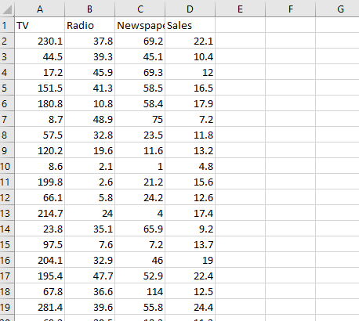

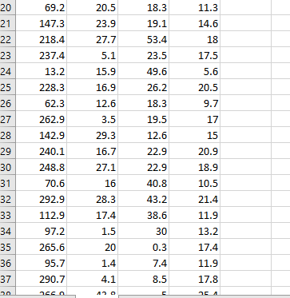

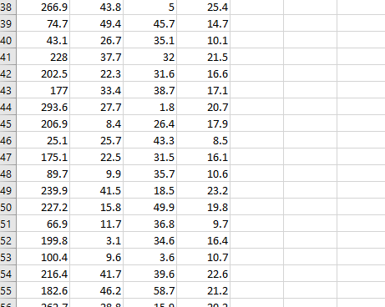

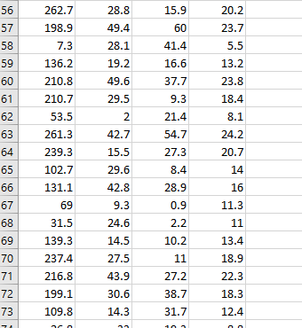

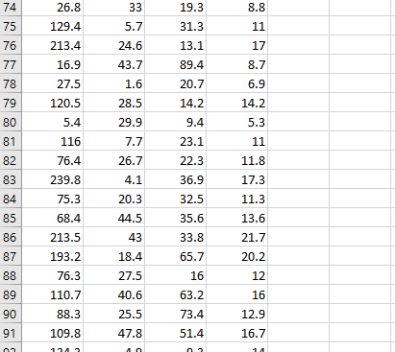

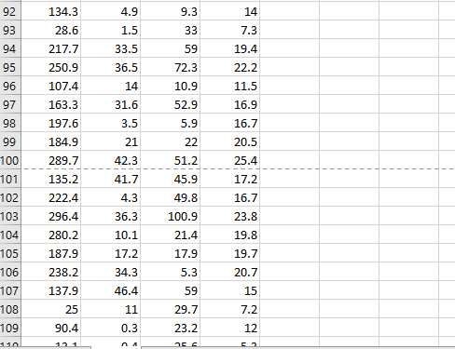

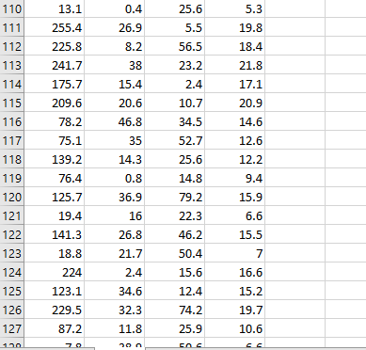

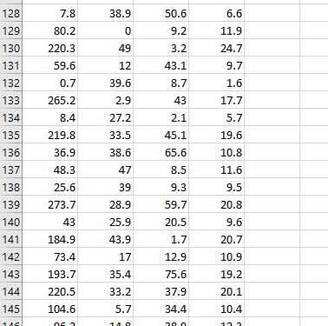

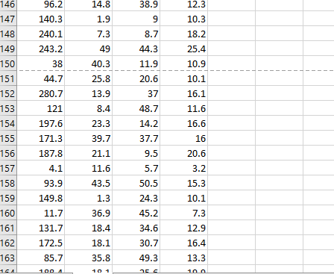

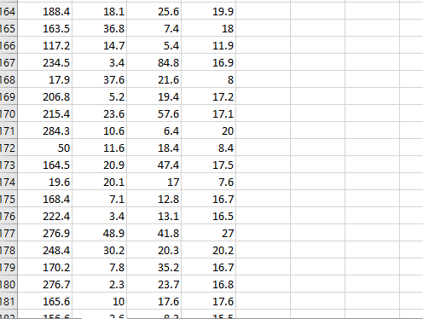

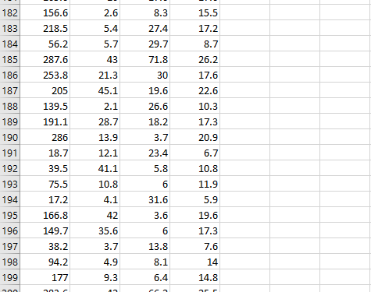



We build the **Stock Price Prediction** model by loading and preprocessing the dataset and we load the historical sales dataset and preprocess the data for analysis.

In the analysis of the "STOCK PRICE PREDICTION" dataset, we conducted a comprehensive series of data analysis steps to create an accurate prediction model. The process began with Exploratory Data Analysis (EDA) to understand the dataset's characteristics. Subsequently, we performed data preprocessing, including outlier detection and handling using the winzoring technique, as well as data normalization using the min-max method. We then developed multiple models, including Linear Regression, Ridge Regression, Lasso Regression, Decision Tree, and Random Forest, all of which were evaluated through cross-validation. The model evaluation results revealed that Random Forest outperformed others, yielding an average Mean Squared Error (MSE) of 10.32%, Root Mean Squared

Error (RMSE) of 8.09%, Mean Absolute Error (MAE) of 5.99%, and an R- squared value of 94.27%. Additionally, we conducted classic assumption tests, including tests for linearity, homoscedasticity, normality, multi collinearity, outliers, and independence, to ensure the validity of our model.These results provide in-depth insights into the quality of our prediction model and its relevance in the context of future sales forecasting.

## Feature Engineering:

Feature engineering includes remodeling raw data into a format that successfully represents the underlying patterns within the data. It involves selecting, combining, and crafting attributes that capture the relationships between variables, enhancing the predictive power of machine learning models. These engineered features acts as the input for algorithms, using progressed performance and robustness.

## Feature Tools:

A python library centered on automated feature engineering, particularly for time- series and relational data. It automates producing new features by leveraging domain-specific knowledge and entity relationships.

**Applications:** Creating time-based features, aggregating data over different time intervals, and handling a couple of associated data tables.

## Features explanation:

* **TV:** This feature represents the amount of advertising budget spent on television media for a product or service in a certain period, for example in thousands of dollars (USD).
* **Radio:** This feature represents the amount of advertising budget spent on radio media in the same period as TV.
* **Newspaper:** This feature represents the amount of advertising budget spent in newspapers or print media in the same period as TV and Radio.
* **Sales:** This feature represents product or service sales data in the same period as advertising expenditure on TV, Radio and Newspaper.

# Load Data Input:

* 1. **import pandas as pd**

df = pd.read_csv('/kaggle/input/stock price prediction/Sales.csv') df.head()

* 1. **import pandas as pd**

df = pd.read_csv('/kaggle/input/stock price prediction/Sales.csv') df.shape()

* 1. **import pandas as pd**

df = pd.read_csv('/kaggle/input/stock price prediction/Sales.csv') df.info()

* 1. **import pandas as pd**

df = pd.read_csv('/kaggle/input/stock price prediction/Sales.csv') df.describe()

## Exploratory Data Analysis (EDA)

* 1. **import plotly.express as px**

figure = px.scatter(df, x='Sales', y='TV', size='TV', trundling='ols', title='Relationship Between Sales and TV Advertising')

figure.update_traces(marker=dict(line=dict(width=2, color='DarkSlateGrey')), selector=dict(mode='markers'))

figure.update_layout( xaxis_title='Sales', yaxis_title='TV Advertising', legend_title='TV Ad Size', pot-boiler='white'

)

figure.show()

* 1. figure= px.scatter(df, x='Sales', y='Newspaper', size='Newspaper', trendline='ols', title='Relationship Between Sales and Newspaper Advertising')

figure.update_traces(marker=dict(line=dict(width=2, color='DarkSlateGrey')), selector=dict(mode='markers'))

figure.update_layout( xaxis_title='Sales', yaxis_title='Newspaper Advertising', legend_title='Newspaper Ad Size', plot_bgcolor='white'

)

figure.show()

* 1. px.scatter(df, x='Sales', y='Radio', size='Radio', trendline='ols', title='Relationship Between Sales and Radio Advertising')

figure.update_traces(marker=dict(line=dict(width=2, color='DarkSlateGrey')), selector=dict(mode='markers'))

figure.update_layout( xaxis_title='Sales', yaxis_title='Radio Advertising', legend_title='Radio Ad Size', plot_bgcolor='white'

)

figure.show()

### Calculate the correlation

correlation = df.corr()

sales_correlation = correlation["Sales"].sort_values(ascending=False)

*# Format and style the correlation values*

styled_sales_correlation = sales_correlation.apply(lambda x: f'**{**x**:**.2f**}**') styled_sales_correlation = styled_sales_correlation.reset_index() styled_sales_correlation. Columns = ["Feature", "Correlation with Sales"] styled_sales_correlation.style.background_gradient(cmap='coolwarm', axis=0)

## Data Preprocessing

* 1. import seaborn as sns import matplotlib.pyplot as plt

*# Create the box plot*

plt.figure(figsize=(8, 6))

sns.boxplot(x='TV', data=df, palette='Blues') plt.title('Box Plot of TV Advertising') plt.xlabel('TV Advertising Spending') plt.grid(axis='x', linestyle='--', alpha=0.6)

*# Show the plot*

plt.show()

1. ***# Create the box plot***

plt.figure(figsize=(8, 6))

sns.boxplot(x='Radio', data=df, palette='Oranges') plt.title('Box Plot of Radio Advertising') plt.xlabel('Radio Advertising Spending') plt.grid(axis='x', linestyle='--', alpha=0.6)

*# Show the plot*

plt.show()

1. ***# Create the box plot***

plt.figure(figsize=(8, 6))

sns.boxplot(x='Newspaper', data=df, palette='YlGnBu')

plt.title('Box Plot of Newspaper Advertising')

plt.xlabel('Newspaper Advertising Spending')

plt.grid(axis='x', linestyle='--', alpha=0.6)

*# Show the plot*

plt.show()

There are outliers in the Newspaper feature. To overcome this, we use the Winsori zing technique. Winsorizing is a technique that replaces outlier values with certain predetermined threshold values. We set the threshold value for the Newspaper feature at 2.

1. import numpy as np

upper_threshold = 2 * np.std(df['Newspaper']) + np.mean(df['Newspaper'])

*# Menerapkan Winsorizing pada kolom 'Newspaper'*

df['Newspaper'] = np.where(df['Newspaper'] > upper_threshold, upper_threshold, d

f['Newspaper'])

### # Create the box plot

plt.figure(figsize=(8, 6))

sns.boxplot(x='Newspaper', data=df, palette='YlGnBu')

plt.title('Box Plot of Newspaper Advertising')

plt.xlabel('Newspaper Advertising Spending')

plt.grid(axis='x', linestyle='--', alpha=0.6)

*# Show the plot*

plt.show()

## Data normalization

At this stage, we use the min-max technique. Min-Max is a data preprocessing technique used in data analysis and machine learning to convert values in a dataset into a certain range, usually between 0 and 1.

1. from sklearn.preprocessing import MinMaxScaler

### Creating a MinMaxScaler object:

scaler = MinMaxScaler()

*# Columns to be normalized (e.g., TV, Radio, Newspaper)*

columns_to_normalize = ['TV', 'Radio', 'Newspaper']

*# Apply Min-Max normalization to the selected columns* df[columns_to_normalize] = scaler.fit_transform(df[columns_to_normalize]) df.head()

## Modelling and Evaluation

At the modeling stage, we use 5 algorithms for comparison, namely Linear Regression, Ridge Regression, Lasso Regression, Decision Tree, and Random Forest. And for evaluation using MSE, RMSE, MAE and R-Squared.

1. X = df[['TV', 'Radio', 'Newspaper']] y = df['Sales']
2. from sklearn.model_selection import cross_val_score num_folds = 5

*Cross validation function is performed and the metrics were calculated in percentage*

def perform_cross_validation(model, X, y, num_folds):

mse_scores = -cross_val_score(model, X, y, cv=num_folds, scoring='neg_mean

_squared_error')

rmse_scores = np.sqrt(mse_scores)

mae_scores = -cross_val_score(model, X, y, cv=num_folds, scoring='neg_mean

_absolute_error')

r2_scores = cross_val_score(model, X, y, cv=num_folds, scoring='r2') return mse_scores, rmse_scores, mae_scores, r2_scores

1. from sklearn.linear_model import LinearRegression, Ridge, Lasso

***# Linear Regression***

linear_model = LinearRegression()

linear_mse, linear_rmse, linear_mae, linear_r2 = perform_cross_validation(linear_ model, X, y, num_folds)

print("Linear Regression:")

print(f"Average MSE: **{**np.mean(linear_mse) / np.mean(y) * 100**:**.2f**}**%")

print(f"Average RMSE: **{**np.mean(linear_rmse) / np.mean(y) * 100**:**.2f**}**%")

print(f"Average MAE: **{**np.mean(linear_mae) / np.mean(y) * 100**:**.2f**}**%")

print(f"Average R-squared: **{**np.mean(linear_r2) * 100**:**.2f**}**%")

print("**\n**")

### # Ridge Regression

ridge_model = Ridge(alpha=1.0) *# You can adjust alpha as needed*

ridge_mse, ridge_rmse, ridge_mae, ridge_r2 = perform_cross_validation(ridge_mo del, X, y, num_folds)

print("Ridge Regression:")

print(f"Average MSE: **{**np.mean(ridge_mse) / np.mean(y) * 100**:**.2f**}**%")

print(f"Average RMSE: **{**np.mean(ridge_rmse) / np.mean(y) * 100**:**.2f**}**%")

print(f"Average MAE: **{**np.mean(ridge_mae) / np.mean(y) * 100**:**.2f**}**%")

print(f"Average R-squared: **{**np.mean(ridge_r2) * 100**:**.2f**}**%")

print("**\n**")

### # Lasso Regression

lasso_model = Lasso(alpha=1.0) *# You can adjust alpha as needed*

lasso_mse, lasso_rmse, lasso_mae, lasso_r2 = perform_cross_validation(lasso_mo del, X, y, num_folds)

print("Lasso Regression:")

print(f"Average MSE: **{**np.mean(lasso_mse) / np.mean(y) * 100**:**.2f**}**%")

print(f"Average RMSE: **{**np.mean(lasso_rmse) / np.mean(y) * 100**:**.2f**}**%")

print(f"Average MAE: **{**np.mean(lasso_mae) / np.mean(y) * 100**:**.2f**}**%")

print(f"Average R-squared: **{**np.mean(lasso_r2) * 100**:**.2f**}**%")

print("**\n**")

1. from sklearn.tree import DecisionTreeRegressor

### # Decision Trees

tree_model = DecisionTreeRegressor(max_depth=None, random_state=0)

tree_mse, tree_rmse, tree_mae, tree_r2 = perform_cross_validation(tree_model, X, y, num_folds)

print("Decision Trees:")

print(f"Average MSE: **{**np.mean(tree_mse) / np.mean(y) * 100**:**.2f**}**%")

print(f"Average RMSE: **{**np.mean(tree_rmse) / np.mean(y) * 100**:**.2f**}**%")

print(f"Average MAE: **{**np.mean(tree_mae) / np.mean(y) * 100**:**.2f**}**%")

print(f"Average R-squared: **{**np.mean(tree_r2) * 100**:**.2f**}**%")

print("**\n**")

1. from sklearn.ensemble import RandomForestRegressor

### # Random Forest

forest_model = RandomForestRegressor(n_estimators=100, random_state=0)

forest_mse, forest_rmse, forest_mae, forest_r2 = perform_cross_validation(forest_ model, X, y, num_folds)

print("Random Forest:")

print(f"Average MSE: **{**np.mean(forest_mse) / np.mean(y) * 100**:**.2f**}**%") print(f"Average RMSE: **{**np.mean(forest_rmse) / np.mean(y) * 100**:**.2f**}**%") print(f"Average MAE: **{**np.mean(forest_mae) / np.mean(y) * 100**:**.2f**}**%") print(f"Average R-squared: **{**np.mean(forest_r2) * 100**:**.2f**}**%")

## Classic assumption test

At the classical assumption testing stage, 5 assumption tests are used, namely linearity test, homoscedasticity test, normality test, multicollinearity test, outliers test, and independent test.

1. import statsmodels.api as sm import statsmodels.stats.api as sms

*# Adding a constant to the independent variables (intercept)*

X = sm.add_constant(X)

*# Fit the regression model*

model = sm.OLS(y, X).fit()

*# Residuals (model residuals)*

residuals = model.resid

1. *Linearity is checked by using Residual vs Fitted values plot*

import matplotlib.pyplot as plt plt.scatter(model.fittedvalues, residuals) plt.xlabel("Fitted Values") plt.ylabel("Residuals")

plt.title("Linearity Check") plt.show()

**24.** *# Assumption 2: Homoskedasticity*

*# You can check homoskedasticity using Breusch-Pagan test*

_, p_homo, _, _ = sms.het_breuschpagan(residuals, X)

print(f"Homoskedasticity (Breusch-Pagan): p-value = **{**p_homo**:**.4f**}**")

**25.** *# Assumption 3: Independence (Serial Correlation)*

*# You can check for serial correlation using Durbin-Watson test*

from statsmodels.stats.stattools import durbin_watson dw_stat = durbin_watson(residuals)

print(f"Serial Correlation (Durbin-Watson): DW Statistic = **{**dw_stat**:**.2f**}**")

**26.** *# Assumption 4: Normality*

*# You can check normality using a normal probability plot (Q-Q plot)*

import scipy.stats as stats

fig, ax = plt.subplots(figsize=(6, 4))

_, ( , , r) = stats.probplot(residuals, plot=ax, fit=True) ax.get_lines()[0].set_markerfacecolor('C0') ax.get_lines()[0].set_markersize(5.0) ax.get_lines()[1].set_linewidth(3.0)

plt.title("Normal Probability Plot")

plt.show()

1. *# Assumption 5: Multicollinearity*

*# You can check Multicollinearity using the Variance Inflation Factor (VIF)*

from statsmodels.stats.outliers_influence import variance_inflation_factor

vif = pd.DataFrame()

vif["Features"] = X.columns

vif["VIF"] = [variance_inflation_factor(X.values, i) for i **in** range(X.shape[1])]

print("Multicollinearity (VIF):")

print(vif)

1. *# Assumption 6: Outliers*

*# You can check for outliers using the studentized residuals and the Cook's Distance*

student_resid = model.get_influence().resid_studentized_internal

cooks_d = model.get_influence().cooks_distance[0]

outliers = pd.DataFrame({'Studentized Residuals': student_resid, "Cook's Distance ": cooks_d})

outliers.index = X.index

print("Outliers:")

print(outliers[outliers['Studentized Residuals'].abs() > 2])

*# You can adjust the threshold as needed*

# OUTPUT;

### 1.

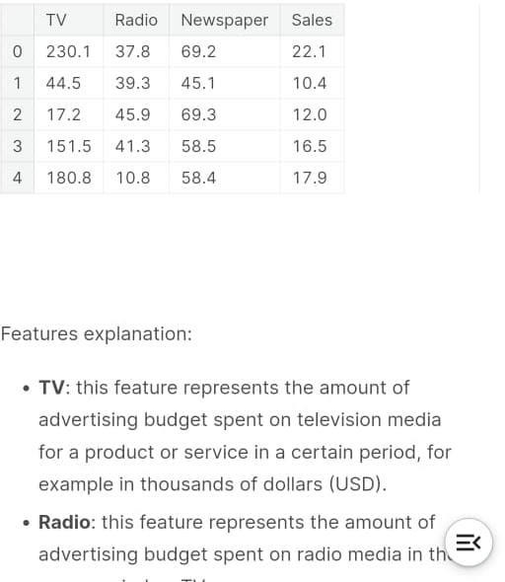

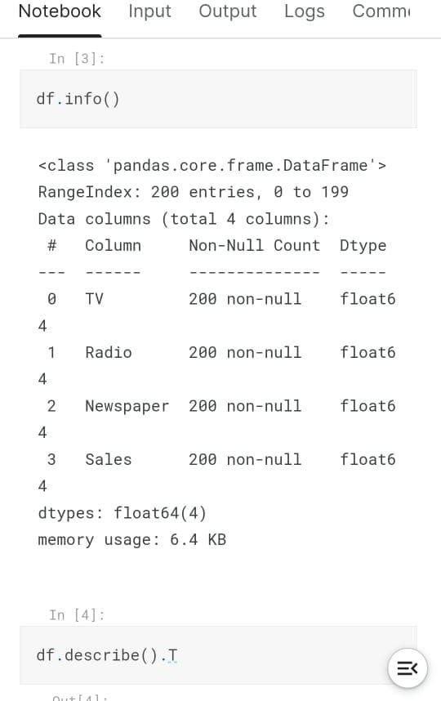***2.***

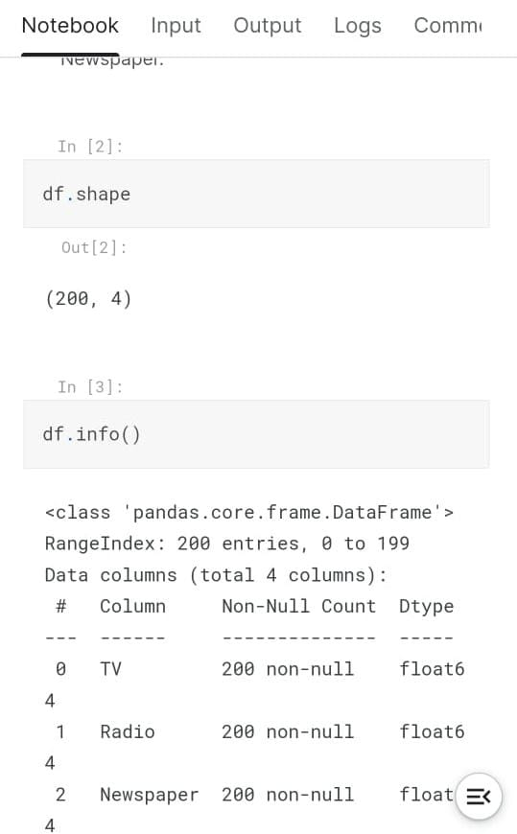***3.***

# CONCLUSION*;*

In report, we will compare a machine learning models like LSTM model, the CNN model and

also the hybrid approach of LSTM + CNN model. We have a tendency to train the model using

the data of NSE listed companies to predict the stock future value.

This is shows the proposed

method is capable to distinctive around interrelation with the data. . Also, it is evident from the

results that, Hybrid approach of LSTM+CNN model is capable to identify the changes in

trends. For the projected method the Hybrid approach of LSTM+CNN is known as the best

model. It uses the information given at a specific instant for prediction. Even if the other two

models LSTM and CNN are utilized in a lot of other time-dependent data analysis, it is not

outperforming over the Hybrid approach of LSTM+CNN architecture in this case. This is often

because of quick changes occur in stock market. The changes in the stock market is not always

be in a regular pattern or not always follow the continuous cycle. Based on the companies and

sectors, the existence of the trends and the period of their existence will differ. The analysis of

this type of cycles and trends can offer a more profit to the investors. In future work, we add

more stock market data and compare more model to improve accuracy of predicted stock price.

In the future, for better accuracy model can be trained with more varied and detailed data. Also,

other algorithms along with proposed can be used to create a new hybrid model.